Calculus 1 Lecture 1.4: Continuity of Functions

Continuity
A curve is continuous if it does not have any “holes”, “breaks” or “asymptotes”

A function is Continuous at a point “c” if:
- 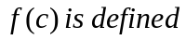
- 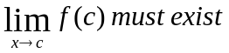
- 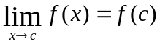
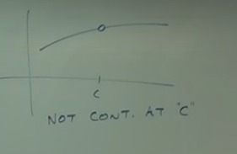
Not continuous at point “c”

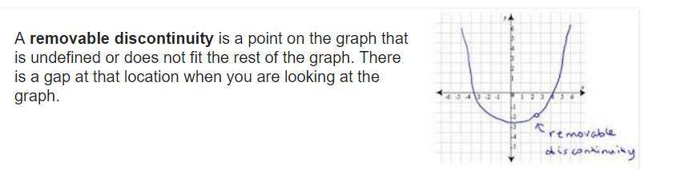

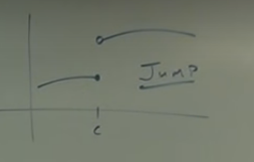

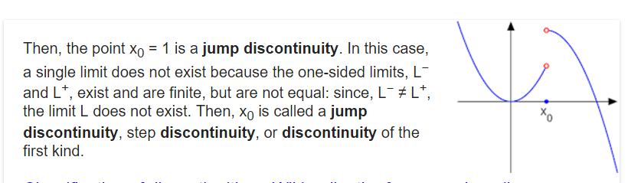

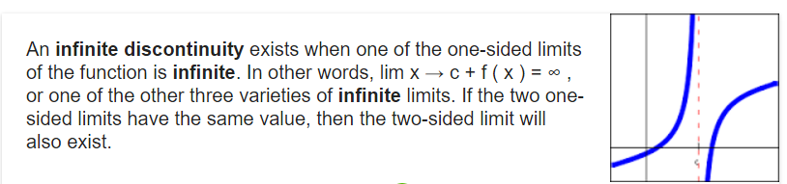

Are these functions continuous at 
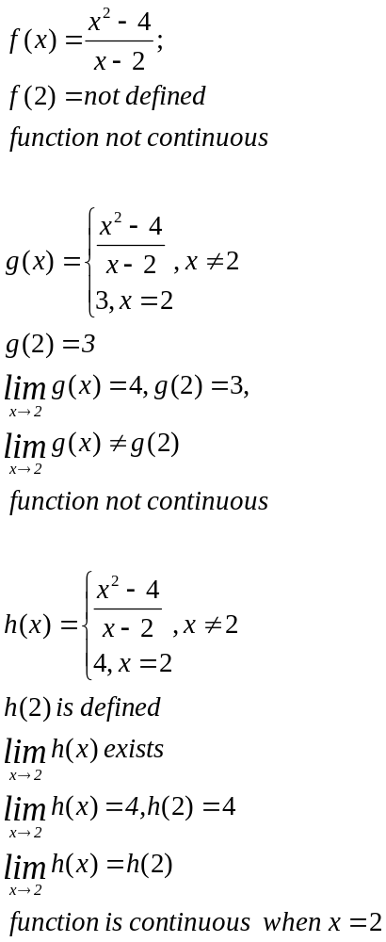

Checking endpoints of a function to determine are they continuous in the function

t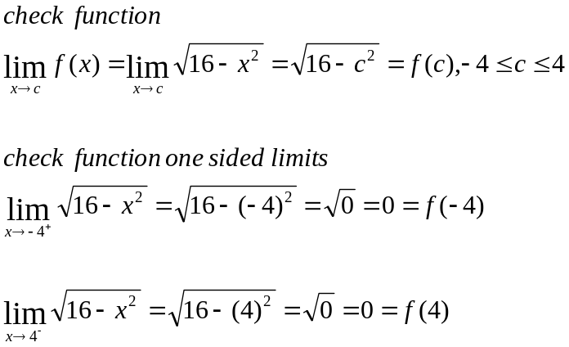

Properties
Function f and g are continuous at point “c”

- f + g are continuous at point “c”
- f - g are continuous at point “c”
- f * g are continuous at point “c”
- f / g are continuous at point “c” unless g(c)=0, then there is a discontinuity at c for f/g

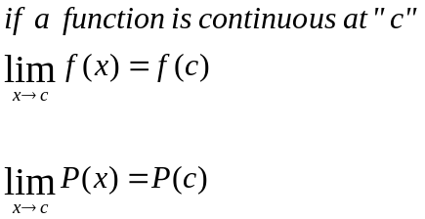
This means
1. Every polynomial is continuous everywhere.
2. A rational function, 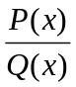, is continuous
everywhere except where the denominator equals zero. At that point there will be a hole or asymptote.

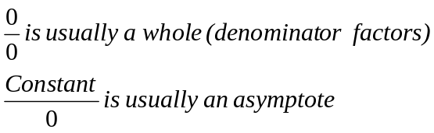

Examples
Find the discontinuities.
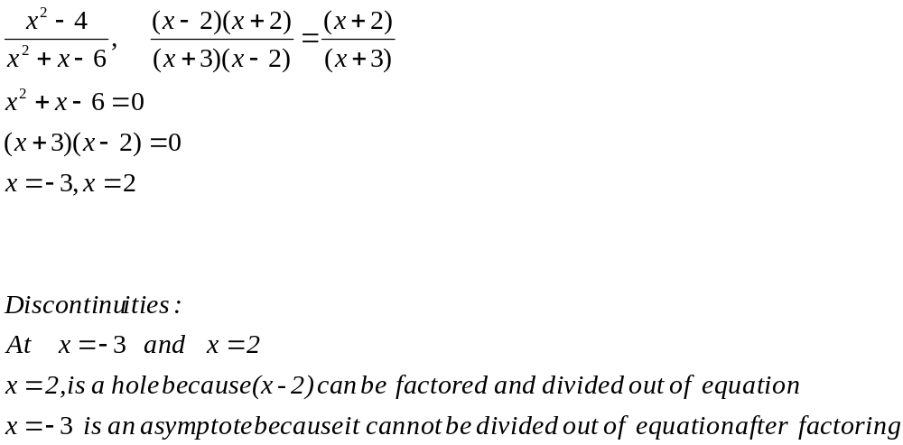

Is
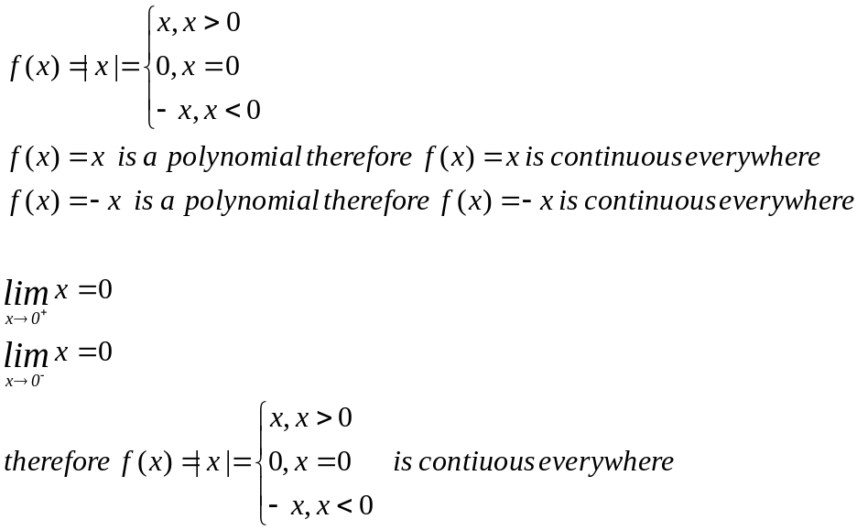
Compositions: (Proof)
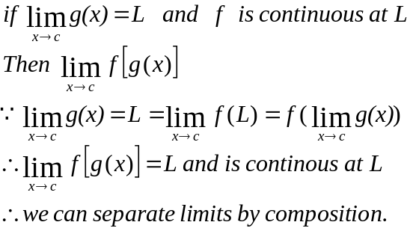

Examples
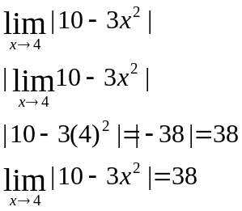

If two functions are continuous everywhere then their composition is continuous everywhere
If a function is continuous in it’s domain it’s inverse will be continuous on it’s respective domain.

NOTE the inverse of a function: the range of the function becomes the inverses domain
The domain of the function becomes the inverses range:

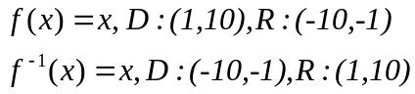
Example

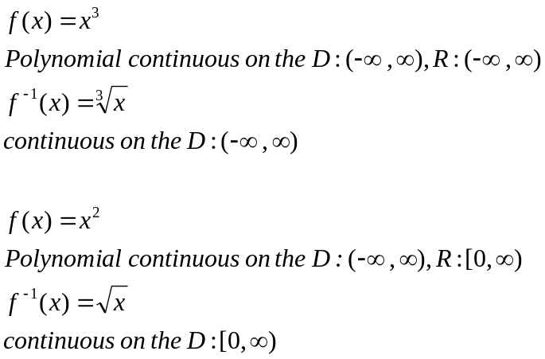

Intermediate value theorem
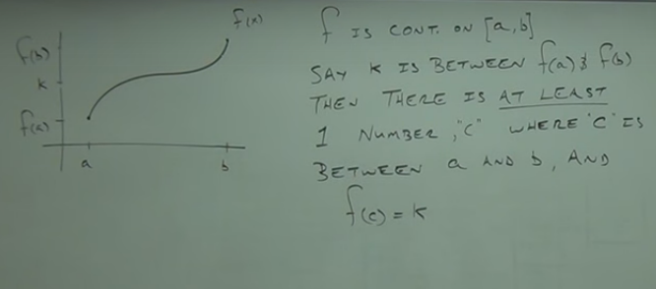

In mathematical analysis, the intermediate value theorem states that if a continuous function, f, with an interval, [a, b], as its domain,
takes values f(a) and f(b) at each end of the interval, then it also takes any value between f(a) and f(b) at some point within the interval.

Example
Approximate roots
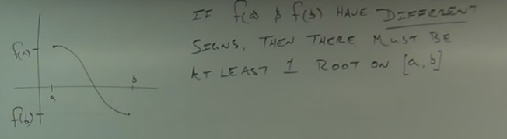

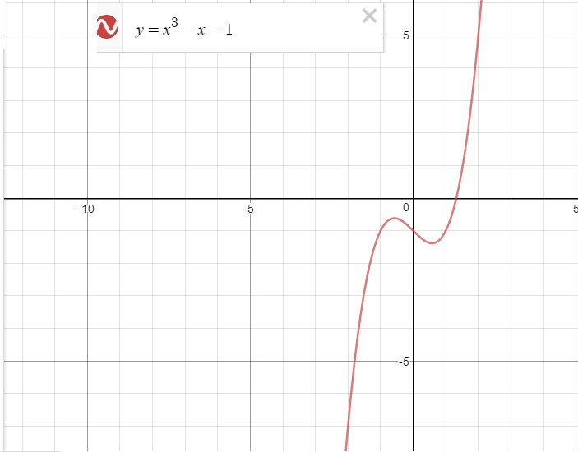

Fill tables with numbers between 1 and 2 to narrow the range when the value changes signs then that is where you
Can set up another table to further narrow the range.

